LSI 2108 SAS Controller Firmware Update Procedure

(A) Using MegaRAID Storage Manager utility under OS

1) Open MSM, Right click on the 2108 controller to be updated and click Update Controller Firmware
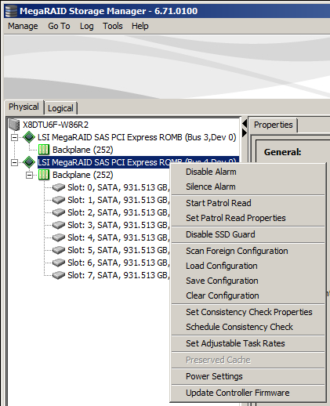

2) Click Browse to search for new firmware
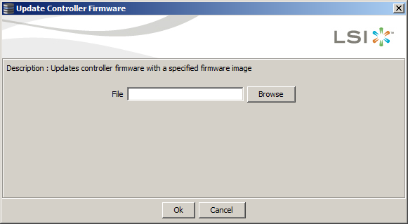

3) Select the new controller firmware AF2108_FW_Image.rom
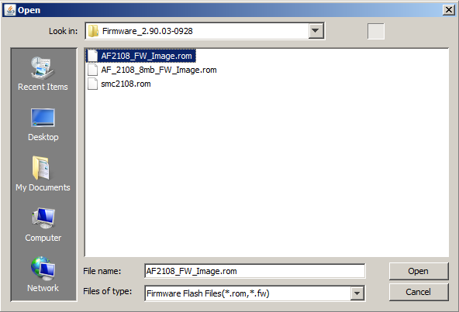

4) Click OK to continue
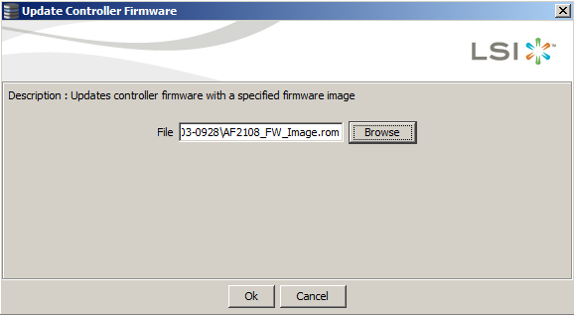

5) Check the “Confirm” box and click OK to continue
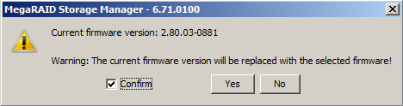

6) Click OK once firmware update completed
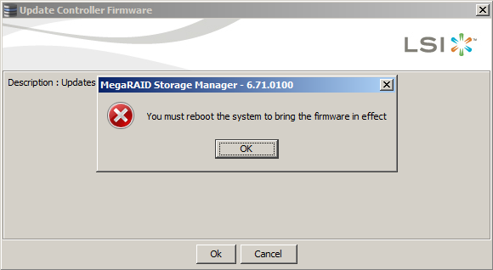

7) Repeat Step 3 and select smc2108.rom to update controller NVData

8) Reboot the system and check firmware version in controller banner during boot
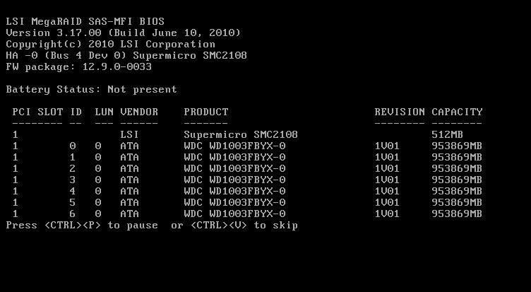
9) Press Ctrl-H to enter controller WebBIOS and select [Controller Properties]
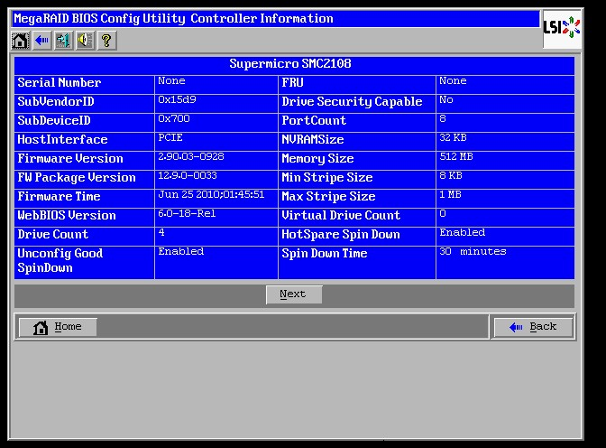

10) Select “Yes” for Set Factory Defaults and then click [Submit]
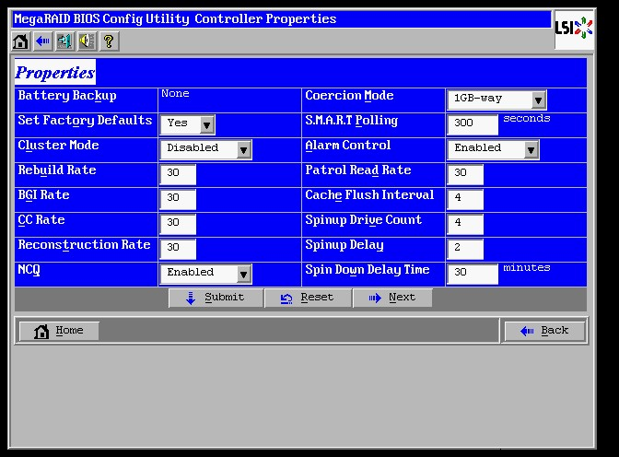
11) Exit WebBIOS and reboot the system

12) Check firmware version using MSM in OS
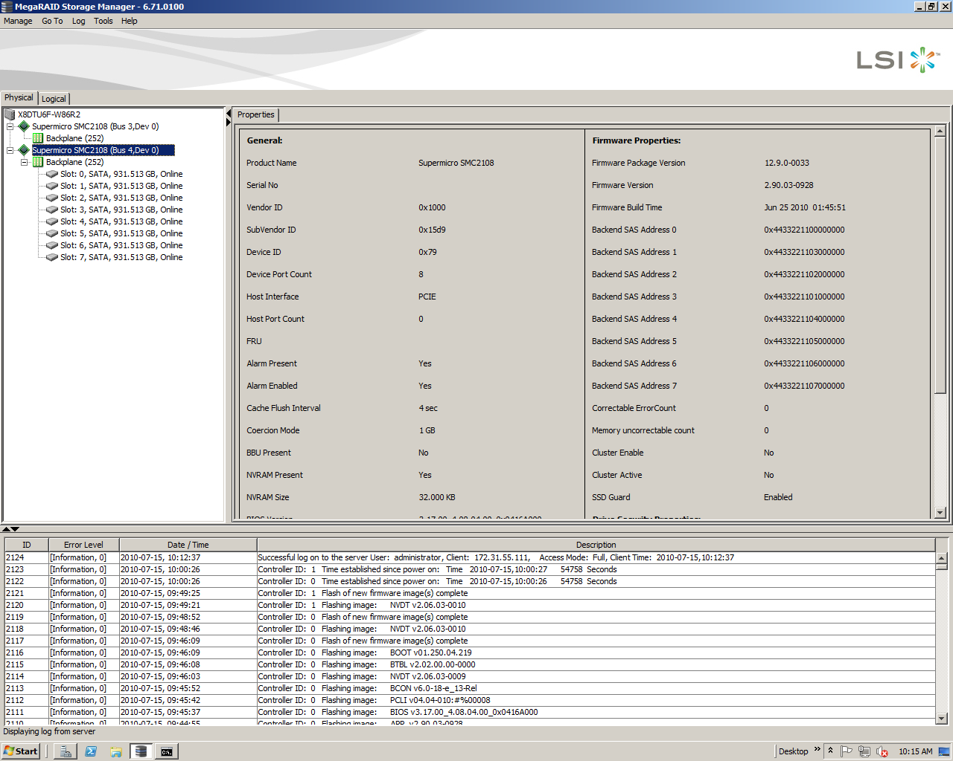

Note: It is recommended to Set Factory Defaults after performed firmware update. User may experience abnormal behavior if did not do so.

(B) Using MegaCli under DOS

1) Boot from USB key and use command Megacli –adpFwFlash –f AF2108_FW_Image.rom –a0
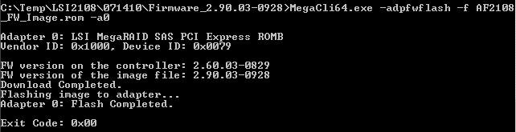

2) Next update controller NVData with Megacli –adpFwFlash –f smc2108.rom –a0
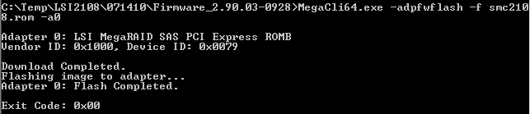

3) Reboot the system and check firmware version in controller banner during boot

4) Press Ctrl-H to enter controller WebBIOS and select [Controller Properties]

5) Select “Yes” for Set Factory Defaults and then click [Submit]

6) Exit WebBIOS and reboot the system

Note: It is recommended to Set Factory Defaults after performed firmware update. User may experience abnormal behavior if did not do so.

